Introduction to AWS CLI
AWS Command Line Interface (CLI) is a powerful tool that enables users to interact with AWS services using commands. It helps automate tasks and manage AWS services efficiently.

AWS CLI Setup and Configuration
Step 1: Install AWS CLI
- Download the AWS CLI installer for your operating system.
- Follow the installation instructions provided here.
Step 2: Configure AWS CLI
Run the following command to configure AWS CLI:
aws configure
Provide the following details:
- Access Key ID
- Secret Access Key
- Default Region
- Output Format (e.g., JSON, table, text)
Step 3: Verify Installation
Run this command to verify:
aws --version

AWS CLI Commands for S3 Management
1. List S3 Buckets
aws s3 ls
2. Create a Bucket
aws s3 mb s3://<bucket-name>
3. Upload a File to S3
aws s3 cp <file-path> s3://<bucket-name>/
4. List Objects in a Bucket
aws s3 ls s3://<bucket-name>/<obj/folder-name> --recursive
5. Delete an Object
aws s3 rm s3://<bucket-name>/<object-key>
6. Sync Local Folder to S3
aws s3 sync <local-folder-path> s3://<bucket-name>/
87. delete all bucket objects from S3 bucket
aws s3 rm s3://cbz14buck --recursive
8. delete empty s3 bucket
aws s3 rb s3://<BUCKET_name>
AWS CLI Commands for EC2 Management
1. List EC2 Instances
aws ec2 describe-instances
2. Start an EC2 Instance
aws ec2 start-instances --instance-ids <instance-id>
3. Stop an EC2 Instance
aws ec2 stop-instances --instance-ids <instance-id>
4. Terminate an EC2 Instance
aws ec2 terminate-instances --instance-ids <instance-id>
5. Create a Key Pair
aws ec2 create-key-pair --key-name <key-name>
6. Create a Security Group
aws ec2 create-security-group --group-name <group-name> --description "<description>"
7. Add Inbound Rule to Security Group
aws ec2 authorize-security-group-ingress --group-id <group-id> --protocol tcp --port 22 --cidr 0.0.0.0/0

AWS CLI Commands for IAM Management
1. List IAM Users
aws iam list-users
2. Create an IAM User
aws iam create-user --user-name <user-name>
3. Attach a Policy to an IAM User
aws iam attach-user-policy --user-name <user-name> --policy-arn <policy-arn>
4. Create an IAM Group
aws iam create-group --group-name <group-name>
5. Add a User to a Group
aws iam add-user-to-group --user-name <user-name> --group-name <group-name>
6. Create a Custom IAM Policy
aws iam create-policy --policy-name <policy-name> --policy-document file://<policy-document.json>

AWS CLI Commands for VPC Management
1. List VPCs
aws ec2 describe-vpcs
2. Create a VPC
aws ec2 create-vpc --cidr-block <CIDR-block>
3. Create a Subnet
aws ec2 create-subnet --vpc-id <vpc-id> --cidr-block <CIDR-block>
4. Create an Internet Gateway
aws ec2 create-internet-gateway
5. Attach Internet Gateway to VPC
aws ec2 attach-internet-gateway --vpc-id <vpc-id> --internet-gateway-id <igw-id>
6. Create a Route Table
aws ec2 create-route-table --vpc-id <vpc-id>
7. Add Route to Route Table
aws ec2 create-route --route-table-id <route-table-id> --destination-cidr-block 0.0.0.0/0 --gateway-id <igw-id>
8. Associate Route Table with Subnet
aws ec2 associate-route-table --subnet-id <subnet-id> --route-table-id <route-table-id>

Practical Demo of CLI Commands
- Configure AWS CLI with a test user.
- Create an S3 bucket, upload a file, and manage permissions.
- Launch an EC2 instance and assign security groups.
- Create a VPC, subnet, and attach an Internet Gateway.
- Test IAM user permissions by creating a policy and restricting actions.
Refer:https://docs.aws.amazon.com/cli/latest/
These hands-on tasks will help reinforce the understanding and practical usage of AWS CLI commands.
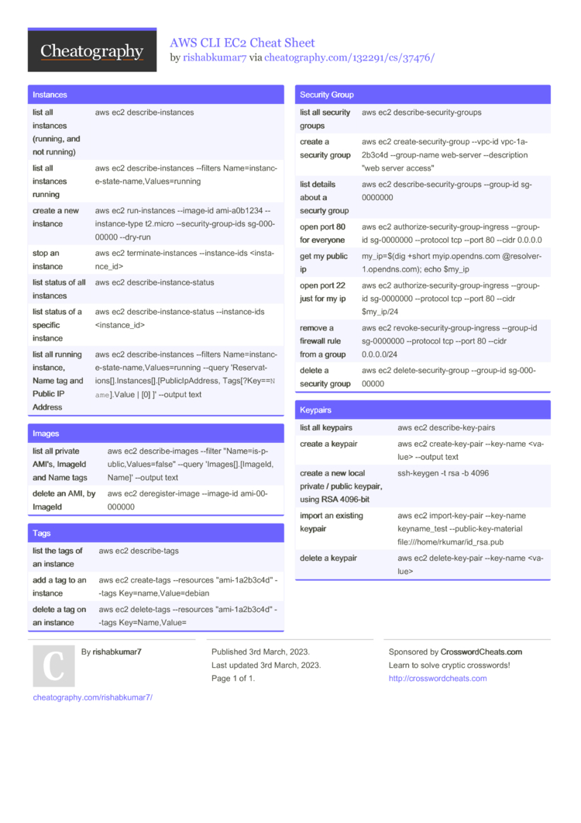
Cheat Sheet-

